Glimpses from few leading Newspapers of Assam regarding the inauguration of the NAGENDRA KUMAR CHMOUAH MEMORIAL OPEN STAGE of Kanya Mahavidyalaya by the Honourable Education Minister ( Govt. of Assam) Dr. Ranoj Pegu on 14-02-2023 .

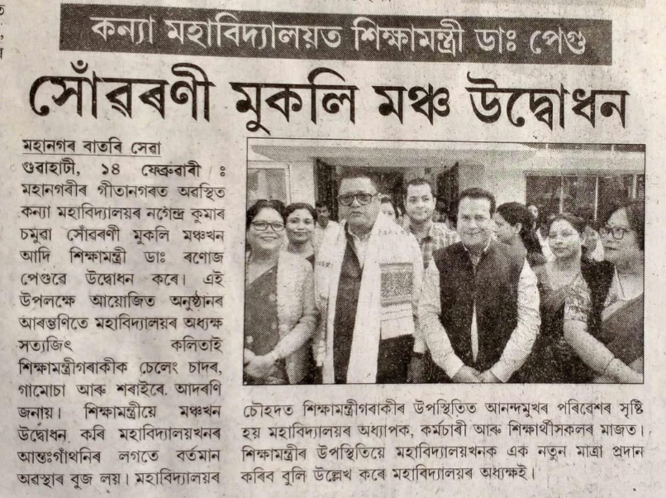

Dainik Assam Published on 15-2-2023.

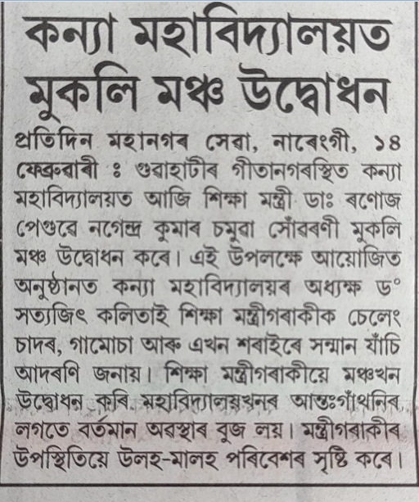

Asomiya Pratidin Published on 15-2-2023.

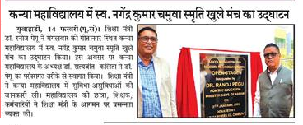

Dainik Purvoday Published on 15-2-2023.

