OFFICE OF THE PROGRAMME OFFICER
NSS UNIT,KANYA MAHAVIDYALAYA
GEETANAGAR, GUWAHATI-781021
Ph-9864109205,Email:- kanyamahavidyalaya1977@gmail.com
Web site:- www.kanyamahavidyalaya.org

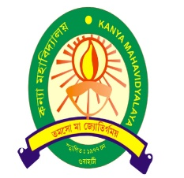
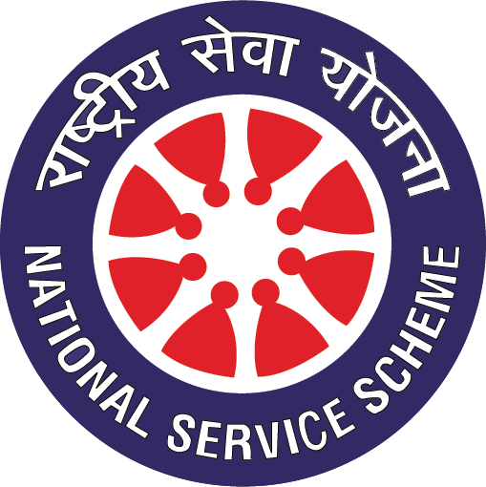

On the occasion of world Diabetes Day NSS Unit, Kanya Mahavidyalaya, Geetanagar organized a Free Diabete Check up Camp in Association with Zestmed Diagnostic & Polyclinic AT kANYA mAHAVIDYALAYA AUDITORIUM.
pRAGRAMME oFFICER
dR. nAMITA bARMAN
nssu, KANYA mAHAVIDYALAYA
dATE:-14/11/2022
